1.5 Surface Area for Solids of Revolution

General Idea:
When a curve is revolved to form a solid we can try to determine the resulting solid’s lateral surface area (surface area excluding the bases of the figure).

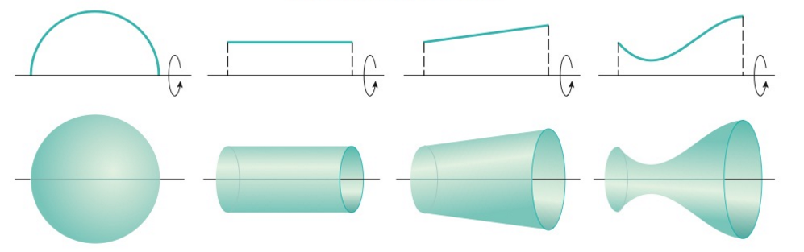

So times this might be easy if we have simple figures. Consider the above. We already know the formula for the surface area of a cylinder is (if we ignore the top and bottom). But how are we supposed to determine the surface area of the figure at the right?

The Specifics:
Suppose we wish to revolve a curve C around an axis and find the surface area of the resulting solid.

Suppose is a nonnegative function with a continuous first derivatives on the interval . Also suppose that a curve C is defined by the equation where . We approximate the length of C in the same way we approximated it in section 2.4.1. Then, to approximate the desired surface area, we revolve the approximate version of C around the x-axis. The pictures below represent this situation.

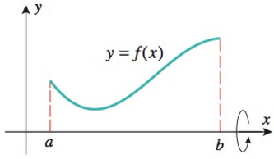
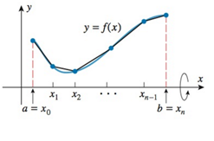

Revolving each of the segments that approximate the curve around the x-axis creates n “bands” each of which is a portion of a right circular cone called a frustum (pictured below). Thus the surface area of each approximating surface can be obtained from the formula:
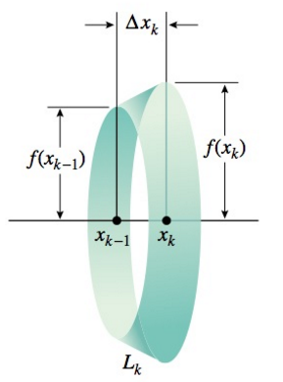
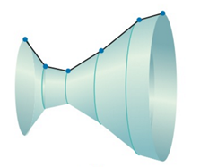
$$l$$
$$r_{1}$$
$$r_{2}$$

So the kth frustum has radii and and slant height. Therefore the lateral surface area of the kth frustum is:

.

We can see that the approximation gets better as n increases. This leads to the following definition:
The lateral surface area of the figure is:

Now, by the mean value theorem we know that there is a number in such that

Using this and the fact that we see that:

Now, by definition we know that the lateral surface area S is given by:
Furthermore, for small we know that since f is continuous and . So another approximation for the lateral surface area is:

Now, we notice that the limit on the right side is a definite integral! In particular,

Now we have derived the following formula.

Definition: Suppose that is nonnegative and has a continuous derivative on , we define the surface area of the solid obtained by rotating the curve where about the x-axis as:

We note that:
where is the arc length differential (see section 2.4.1 for definition of arc length differential).

Thus, if the curve is described as where then the formula is:

Definition: Suppose that is nonnegative and has a continuous derivative on , we define the surface area of the solid obtained by rotating the curve where about the y-axis as:

Thus, if the curve is described as where then the formula is:
Note: In these definitions we are not able to put limits of integration on the integrals involving the arc length differential because we do not know limits on the s.
Example 1: Find the exact surface area of the figure obtained by rotating the curve where about the x-axis.

Setup:
We note that is nonnegative and has a continuous derivative on .
So, by definition the desired surface area is given by:
OR

The first integral is easier to evaluate so we will choose to evaluate that one.

Evaluate:
Let and thus .
Our limits of integration become: .

Example 2: Set up, but do not evaluate, an integral which yields the exact surface area of the figure obtained by rotating the curve where about the y-axis.

Setup:
Since we are revolving around the y-axis we will set up an integral with respect to y. Therefore we need to solve our equation for x.
where

We note that is nonnegative and has a continuous derivative on .
So, by definition the desired surface area is given by:
OR
Example 3: Set up, but do not evaluate, an integral which yields the exact surface area of the figure obtained by rotating the curve where about the y-axis.

Setup:
We note that is nonnegative and has a continuous derivative on .
While we typically would set this integral up with respect to y (since we are revolving about the y-axis) solve for x would be very difficult. Therefore we will set this integral up with respect to x.
So, by definition the desired surface area is given by:

Example 4: Determine the exact area of the surface generated by revolving where about the x-axis.

Setup:
We note that is nonnegative and has a continuous derivative on .
So, by definition the desired surface area is given by:
OR

Note: The second integral is easier to evaluate, however I will show how to integrate both.
Evaluate:
Let and thus .
Our limits of integration become: .

OR

Let and thus .
Our limits of integration become: .

Note: We can confirm with a calculator that .

